**F ras er Val ley B rain Injury As s ociation**

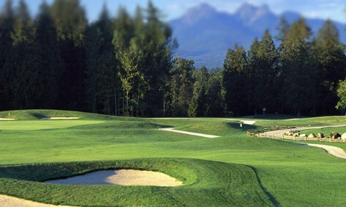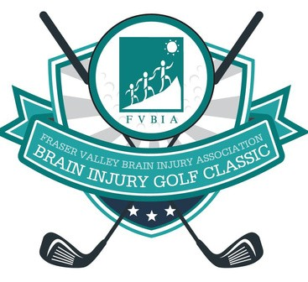

**BRAIN INJURY**

Golf Classic

2025

**Redwoods Golf Course**

**22011 88th Ave., Langley, BC**

Wednesday September 17 2025

[**SPONSORSHIP & PLAYER REGISTRATION NOW OPEN!**](https://bit.ly/3EmfDze)

**Click here or Go to**[**: fvbia-brain-injury-golf-classic-2025.eventbrite.ca**](https://bit.ly/3EmfDze)

**Fraser Valley Brain Injury Association**

**BRAIN INJURY**

Golf Classic

Dear Friends:

We are excited to be back at the beautiful Redwoods Golf Course this year for the annual Brain Injury Golf Classic.

Since 1997, the Fraser Valley Brain Injury Association has been working as an advocate for people of all ages with acquired brain injuries and striving for the development of appropriate services, opportunities, rehabilitation and training for all survivors of brain injury throughout the Fraser Valley.

We are dedicating this year's tournament to John Simpson, our founder and long-time advocate in the brain injury community.

Please join us for a great day of golf, fun, fundraising and memories!

Your participation and sponsorship contributions will help preserve the high quality of support and services offered to people with acquired brain injuries and their families that FVBIA has provided for the past 27 years.

**Early Bird Registration: $225** - Opens March 1st / Register and Pay by July 31, 2025

**Regular Registration: $250** - Opens August 1st

Even if you can't join us for golf, **you can still help by**: Sponsoring a hole or contest

Purchasing a ticket to the Dinner

Donating prizes for the auction or golf teams Purchasing 50/50 Tickets

Purchasing dinner tickets for $80/each Sponsoring a golfer who has a brain injury

**Tournament Partner**

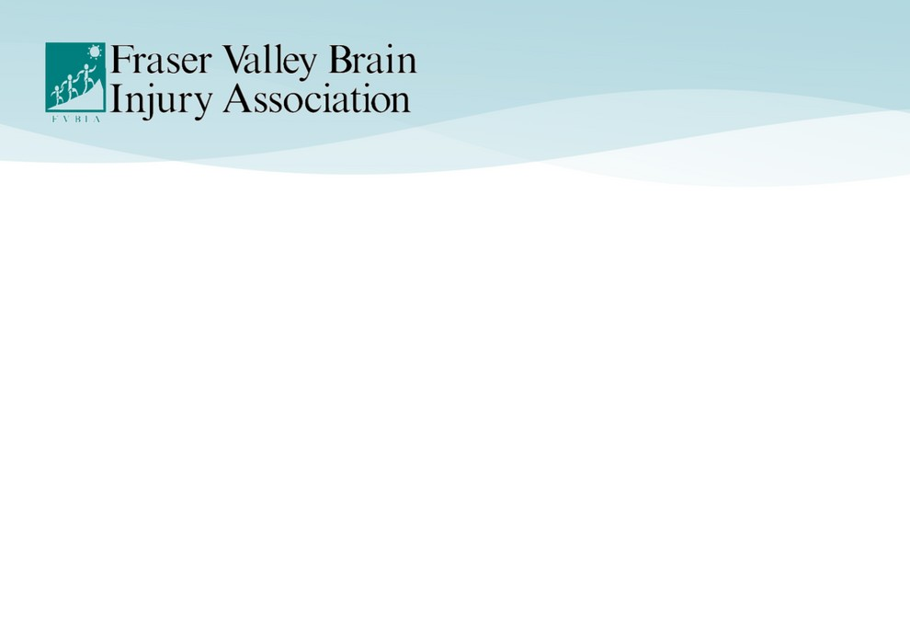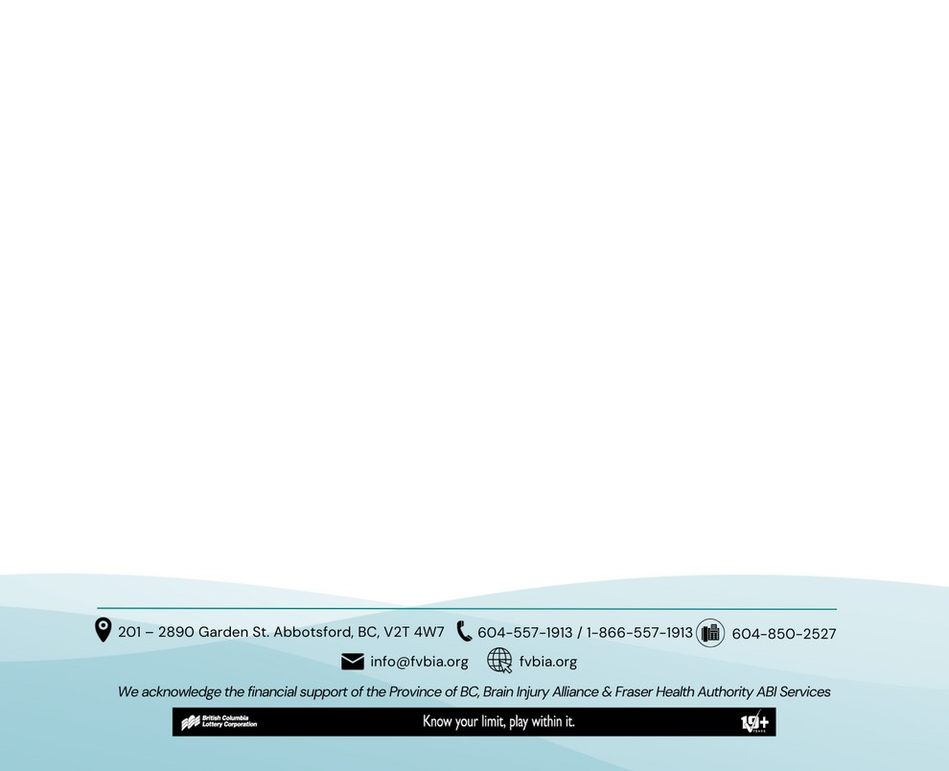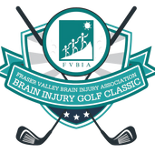

Please contact Fraser Valley Brain Injury Association at 604-557-1913, 1-866-557-1913 (toll-free) or

[info@fvbia.org](mailto:info@fvbia.org) for more information.

Thanks for your support!

Sincerely,

Carol Paetkau, Executive Director, Fraser Valley Brain Injury Association

**2**

**Tournament Partner: $4,500**

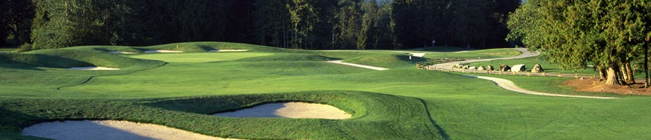

Two (2) foursomes for the event

(8 Golfers, Power Carts, Lunch & Dinner) One additional table of 8 at dinner Signage on the first hole tee deck & green Signage at dinner

Logo/Company name on golf cart cards & scorecard

**~~Cannon Long Drive (1 only): $3,200~~ SOLD**

One (1) foursome for the event

(4 Golfers, Power Carts, Lunch & Dinner) Acknowledgement during prize announcements Signage on hole tee deck & green

## Golf Cart Sponsor: $2,700

One (1) foursome for the event

(4 Golfers, Power Carts, Lunch & Dinner) Logo/Company name displayed on golf cart cards Signage by the golf cart area

## Putting Contest (1 only) $2,700

One (1) foursome for the event

(4 Golfers, Power Carts, Lunch & Dinner) Acknowledgement during prize announcements Logo/Company name on pin flag

## Contest Sponsors: $1,850

One (1) foursome for the event (4 Golfers, Power Carts, Lunch & Dinner)

Acknowledgement during prize announcements  Marshmallow Long Drive (1 only)

 Men’s Long Drive Contest

 Men’s Closest to the Pin Contest

 Women’s Long Drive Contest **SOLD**

 W**--**o**--**m**---**e**-**n**--**’s**---**C**--**lo**--**s**--**e**-**s**--**t**-**t**-**o**--**t**-**h**--**e**--**P**--**i**-**n**--**C**---**o**-**n**--**t**-**e**-**s**--**t **SOLD**

## Hole In One Sponsor: $1,500

Signage at designated tee box of contest.

The opportunity for 2 company representatives to network & hand out company "swag" at your hole. Dinner for 2 representatives.

## Hole Sponsors: $1,200

Signage at designated tee box of contest

The opportunity for 2 company representatives to network & hand out company "swag" at your hole. Dinner for 2 representatives.

## Candy Bag Sponsor: $1,200

Signage at designated tee box of hole.

The opportunity for 2 company representatives to hand out candy bags at your hole.

Dinner for 2 representatives.

## Tailgate Brunch Sponsor: $1,000

Signage at Tailgate Brunch. Dinner for 2 representatives.

## Dinner Sponsor: $1,000

Signage at Dinner.

Dinner for 2 representatives.

### Golfer with a Brain Injury Sponsor: $250

Signage at Dinner.

## Donations

Please consider donating to this event. You can donate golfer prizes, swag for golfer goodie bags or silent auction items as well as financial contributions.

All contributions are deeply appreciated!

[**Sponsorship opportunities can be purchased online at:**](https://bit.ly/3UhD1Dn)

**h** [**ttp://fvbia-brain-injury-golf-classic-2025.eventbrite.ca**](http://fvbia-brain-injury-golf-classic-2025.eventbrite.ca/)

**3**

All sponsors will be recognized with company logo/name on social media, at registration, & signage on the course. Sponsors are encouraged to set up and staff a table or activity at a hole for networking & golfer giveaways. Outside alcohol or food is prohibited. Contact us at [info@fvbia.org](mailto:info@fvbia.org) to discuss options.

#### All Registration Closes September 10, 2025

**REGISTRATION**

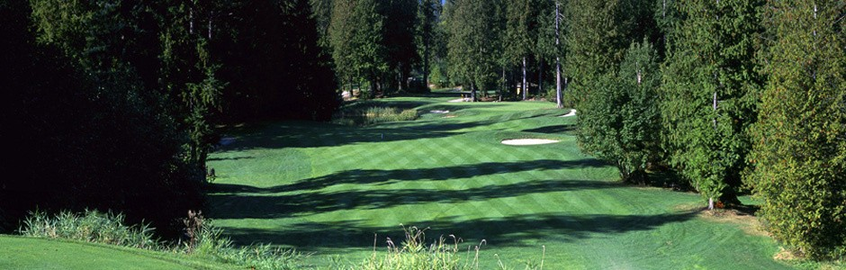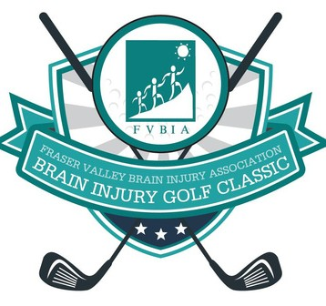

**Fraser Valley Brain Injury Association**

**BRAIN INJURY**

Golf Classic

**Early Bird**

**Opens March 1 / Closes July 31**

*Must register & pay by July 31st*

Includes 18 holes of golf, cart, tailgate brunch and dinner.

**$225.00**

**Regular**

**Opens August 1 / Closes Sept 10** *Please register by September 10th* Includes 18 holes of golf,

cart, tailgate brunch and dinner.

**$250.00**

**Scan to Register Online\***

or go to:

[**f vbia-brain-injury-golf-classic-2025.eventbrite.ca**](http://fvbia-brain-injury-golf-classic-2025.eventbrite.ca/)

**4**

**WILL YOU BE REGISTERING A TEAM or MORE THAN ONE PLAYER?**

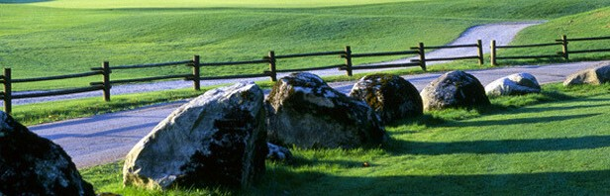

**Fraser Valley Brain Injury Association**

**BRAIN INJURY**

Golf Classic

**We still need to collect info for the other Players!**

After purchasing your tickets, please follow the instructions in “Additional Information” at the bottom of your confirmation ticket email to register other players in your team.



**1**

**Go to FVBIA’s Eventbrite Registration to Order Your Tickets**

Choose your Sponsorship and / or Registration Level on the FVBIA Eventbrite Registration

page at: **f** [**vbia-brain-injury-golf-classic-2025.eventbrite.ca**](https://fvbia-brain-injury-golf-classic-2025.eventbrite.ca/)

**2**

**Confirm Your Order and Receive Your Tickets**

Check your order and choose your payment method to confirm. You will receive an email

with your Ticket Confirmation and “Additional Information”

**3**

[**If You Register a Team or More Than One Player, go to**](https://forms.gle/vprTCR7G21UHc6dN8)

[**forms.gle/vprTCR7G21UHc6dN8 to register each team player**](https://forms.gle/vprTCR7G21UHc6dN8)

#### If you are only registering yourself as a Single Player, you can skip this step.

**Polish Your Clubs & Get Ready for a DAY PACKED WITH FUN and PRIZES!**

**4**

And don’t forget to tell your friends and colleagues about the great cause you will be playing for on Wednesday, September 17 2025, at Redwoods Golf Course! See you on the green!

**4**

**Fraser Valley Brain Injury Association**

**Thank you to our 2025 Golf Classic Sponsors**



**Chris Gledhill & Robin Newbery**







**Thank you to our donors**

**Carol Paetkau**